Practical - 6
WEB DEVELOPMENT FRAMEWORKS (ITUE203)
SEMESTER: 3RD, 2026-27
ID: 25DCE110

Practical Title: Rendering External JSON Data using Fetch API, Search and Filter

Display event lists, student profiles, notices, or FAQs from external JSON files using Fetch API. Implement dynamic rendering, search, filter, sorting, and pagination.

Theory
- How is JSON fetched, parsed, and rendered?
The fetch() method is used to load data from external JSON files like events.json, students.json, and faqs.json. The response.json() method converts the response into JavaScript data, which is displayed dynamically on the webpage using JavaScript and DOM elements.
- Which array methods are used for search, filter, sort, and pagination?
The .filter() method is used to search and filter records, .sort() arranges records in order, .map() creates HTML content for displaying data, and .slice() selects records for pagination. These methods help manage and display data easily.
- How are loading and error states handled?
A loading message is displayed while the JSON data is being fetched. If the data loads successfully, it is displayed on the webpage. If an error occurs, an error message is shown so the user knows that the data could not be loaded.
- How is modularity maintained in JavaScript files?
Modularity is maintained by keeping JavaScript code in separate files and using functions for different tasks. For example, practical6.js handles fetching and displaying JSON data. This makes the code easier to understand, maintain, and reuse.

Implementation/ Output/Result
Tags:
1. How is JSON fetched, parsed, and rendered?
- fetch() → Fetches data from a JSON file.
- response.json() → Converts JSON data into JavaScript data.
- DOM → Displays the data on the webpage.
2. Which array methods are used?
- filter() → Searches and filters data.
- sort() → Arranges data in order.
- map() → Creates content for display.
- slice() → Selects data for pagination.
3. How are loading and error states handled?
- Loading message → Displays while data is loading.
- try...catch → Handles errors.
- Error message → Displays when data fails to load.
4. How is modularity maintained in JavaScript files?
- Separate files → Keep code organized.
- Functions → Divide tasks into smaller parts.
- Reusability → Makes code easier to maintain and reuse.

Output Screenshots:
Eventspage:
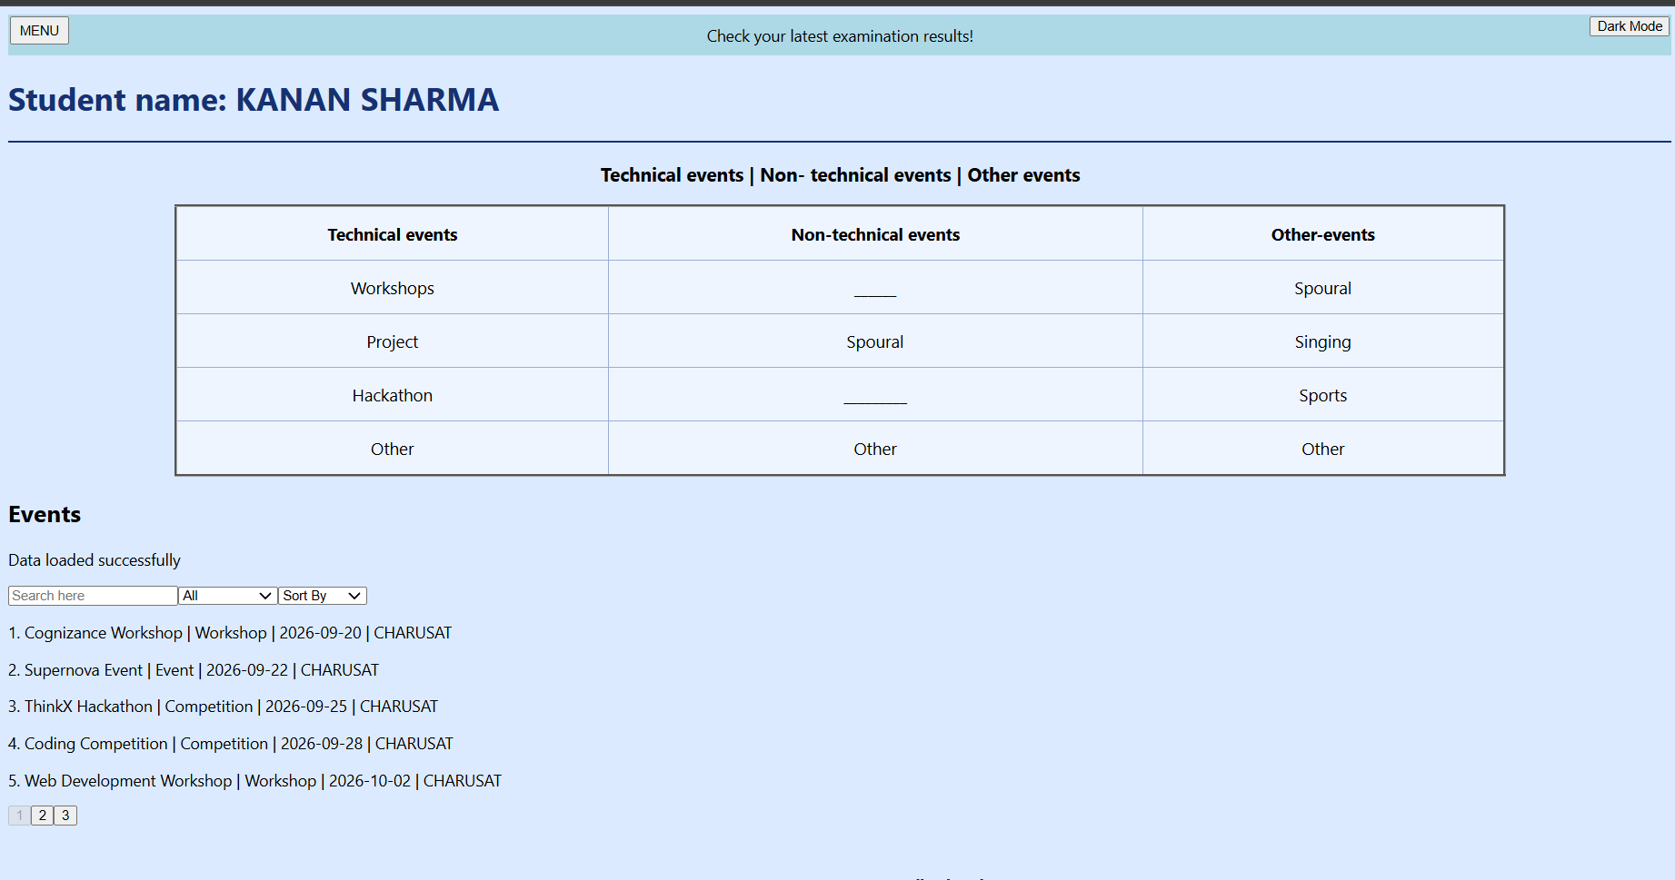
Search:
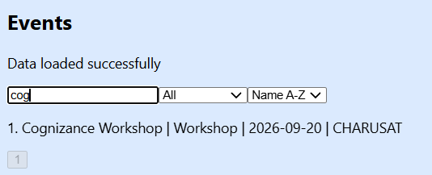

Sort:
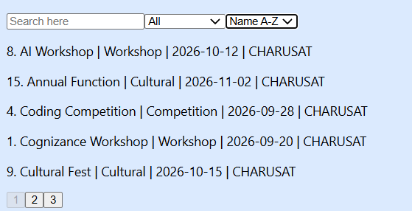
Studentdashboard:


FAQs:
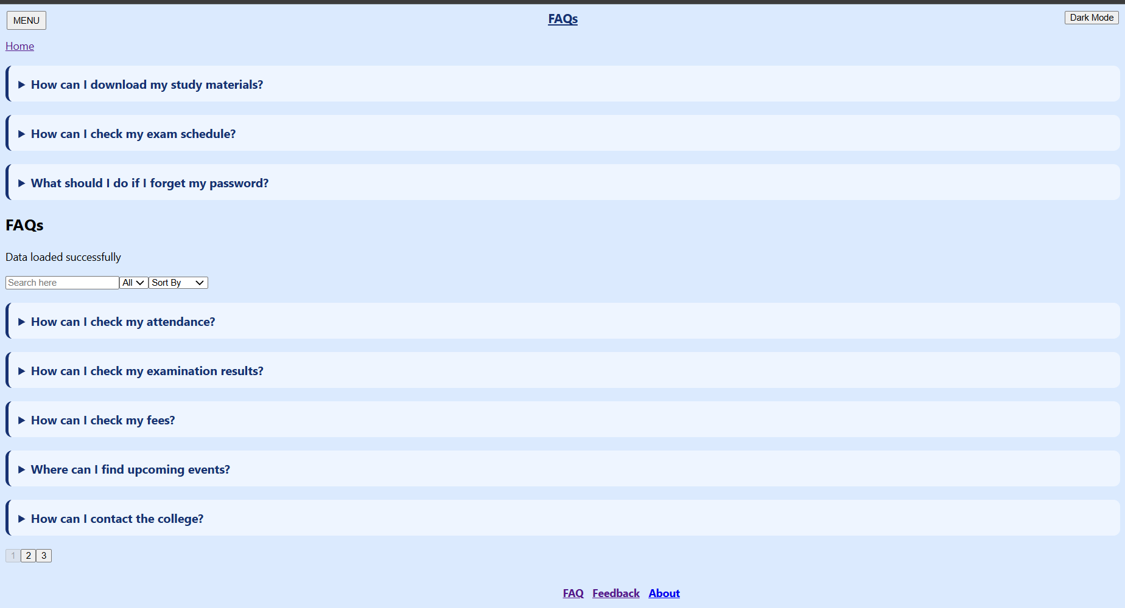
Search:
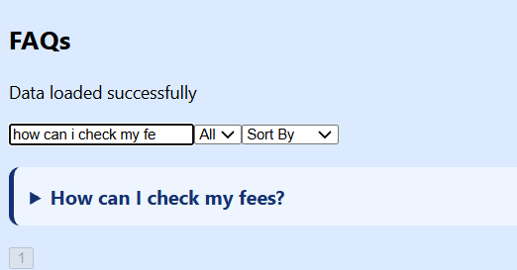

GitHub Repository Link:

https://github.com/kanan2007s-sys/Web-development-/tree/main

Challenges Faced:

It was very difficult to fetch the data from JSON file.

Learning Outcomes:
Learned to fetch, parse, and display JSON data dynamically using JavaScript, with search, filtering, sorting, and pagination.

Faculty Remarks:

